Summary Report ([Github repo](https://github.com/minghao51/STForecast))

# Data and Charts

* Notebook & Code ([basic_plot_explore.ipynb](https://github.com/minghao51/STForecast/blob/master/basic_plot_explore.ipynb))
* Word Document with all the extracted Charts ([Daily_Monthly_Yearly_Charts.docx](https://github.com/minghao51/STForecast/blob/master/Daily_Monthly_Yearly_Charts.docx))

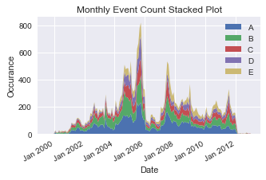

* Daily Chats are generally too noisy, with too many noises and overlaps between data points, it does not depict well in a static chart.
* Stacked Monthly Charts portray the trends between area with most clarity.
* Yearly Charts are too coarse.
* All the charts can be found in the notebook/word document.

# One-Day forecast Model

* Notebook & Code ([tf_forecast.ipynb](https://colab.research.google.com/drive/1dGhjQgkcGE733Eq_awsGUhw-XQZ4MiOy?usp=sharing))
* Word Document with more details ([Model_One_Day_forecast.docx](https://github.com/minghao51/STForecast/blob/master/Model_One_Day_forecast.docx))

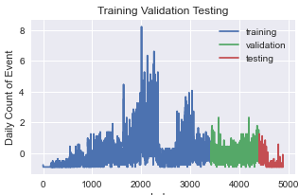The most successful model that is built for the one-day forecast on total number of daily occurrences is the **Residual LSTM.**

**The Model is built through**

1. Normalized Input (Daily Event Counts)
2. Splitting Data Windows for Input of 30 Daily Event Counts
3. 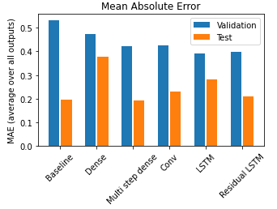LSTM with 32 Nodes + Residual

**To ensure that the model is generalisable and adapt well to unknown data.**

* It is Trained, Test, Validated on different snapshots of data
* Walk forward (with respective to Data window) prediction with 1-day forecast and evaluate on MAE (Mean Absolute Error), MSE (Mean Square Error) with testing data.